 | EFP | www.foresight-platform.eu
The European Foresight Platform
supporting forward looking decision making

Research Priorities for
Digital Creative Industries in Europe

Foresight Brief No. 171

Authors: | Sabine Hafner-Zimmermann, Steinbeis-Europa-Zentrum, hafner@steinbeis-europa.de  Dr. Björn Sautter, Steinbeis-Europa-Zentrum, sautter@steinbeis-europa.de  Dr. Günter Clar, Steinbeis-Europa-Zentrum, clar@steinbeis-europa.de
Sponsors: | European Commission (DG Research), participating regions
Type: | Single issue brief
Organizer: | MFG Baden-Württemberg GmbH Stuttgart, Steinbeis-Europa-Zentrum, Stuttgart, Germany
Duration: | 3/2008-12/2010 | Budget: | 11m EUR | Time Horizon: | 2020 | Date of Brief: | March 2010

Purpose
With creativity and strategy, the CReATE project designed and implemented a novel strategic cluster development approach integrating Strategic Policy Intelligence tools (such as foresight and impact assessment) and direct innovation support instruments. Guided by a transregional framework and based on very different regional strengths and research, technology development and innovation (RTDI) support histories, it aimed at fostering cross-cluster and transregional learning and knowledge exchange more effectively and successfully. In an iterative process, alternating between and mutually enriching the regional and the trans-regional levels, research priorities for information and communication technology innovations in “Culture and Creative Industries” were identified. Strongly related to their “fields of excellence & fields of aspiration” (the existing strengths but also the future development trajectories set by the regional stakeholders), the strategic capabilities of the different stakeholder groups were strengthened and a strategic joint research agenda was developed. On this base, broader and more far-reaching activities will be developed regionally and trans-regionally, also involving partners from outside the consortium and optimising regional, national and EU programmes from RTDI and other policy fields.

Strategic Importance
of Creative Industries
To emerge invigorated from the current economic crisis is the most important challenge for the European economies, societies, policies and the European Union as a whole. New sources of sustainable growth must be tapped, creating new jobs and markets for European citizens and companies.
It is of strategic importance to better harness the potential of innovation and knowledge cutting across and connecting all sectors, and to better coordinate priority setting and programme design between regional, national and EU levels in order to tap synergies of actions and policies.
In this respect, the Culture and Creative Industries (CI) based on state-of-the-art information and communication technologies (ICT) play a strategic role. The CI sector is one of the emerging lead markets of the European knowledge economy, already ranks fourth in EU GDP contribution (626 bn € in 2007). As ICT constitute the technology base enabling the development of innovative CI products and services, research progress in ICT is a key ingredient for sustaining competitive CI. Therefore, it is a good investment to support ICT research and to encourage a more systematic and forward-looking use of its innovation potential. To fully harness this potential, it is important to develop new strategic guidance and RTDI support schemes, as the CI sector is characterised by a comparatively high percentage of micro-enterprises and non-conventional forms of employment.
The CI employment growth rate has been double that of the general economy in recent years and is forecast to continue at an average of 10 % annually. Cooperation with CI enterprises increases the innovativeness in all sectors, and regional CI specialisation explains about half of the variance of GDP/capita. Efficient knowledge generation and its creative application can transform the traditional industrial landscape into a competitive industry base and modern service sector, thus contributing to the generation of new markets and high-quality jobs.
In its EU 2020 proposal to the Council in March 2010, the European Commission highlights the importance of creativity and knowledge creation for sustained and sustainable growth. It aims at an impetus for overcoming the current crisis and advocates a new approach that explicitly addresses the complex interdependence between all governance levels.
Often, the main challenge for effective decision-making is the distributed nature of knowledge. SPI tools provide public and private decision-makers with comprehensive, objective, and forward-looking information (e.g. on long-term developments, global trends, societal and individual values, etc). Applied consecutively and consistently, they can help identify, select, structure and ‘translate’ all available information, thereby enabling the development of better decisions and policies.
The concept of a simplified policy support cycle (see graph) can help take this better into account for improving policies and programmes. It facilitates the analyses of decision-making processes and identifies the tools necessary to optimise the outcomes at each stage. Strategic policy intelligence (SPI) tools include technology or territorial foresight, innovation and technology assessment, roadmapping, evaluations and other interactive exercises.
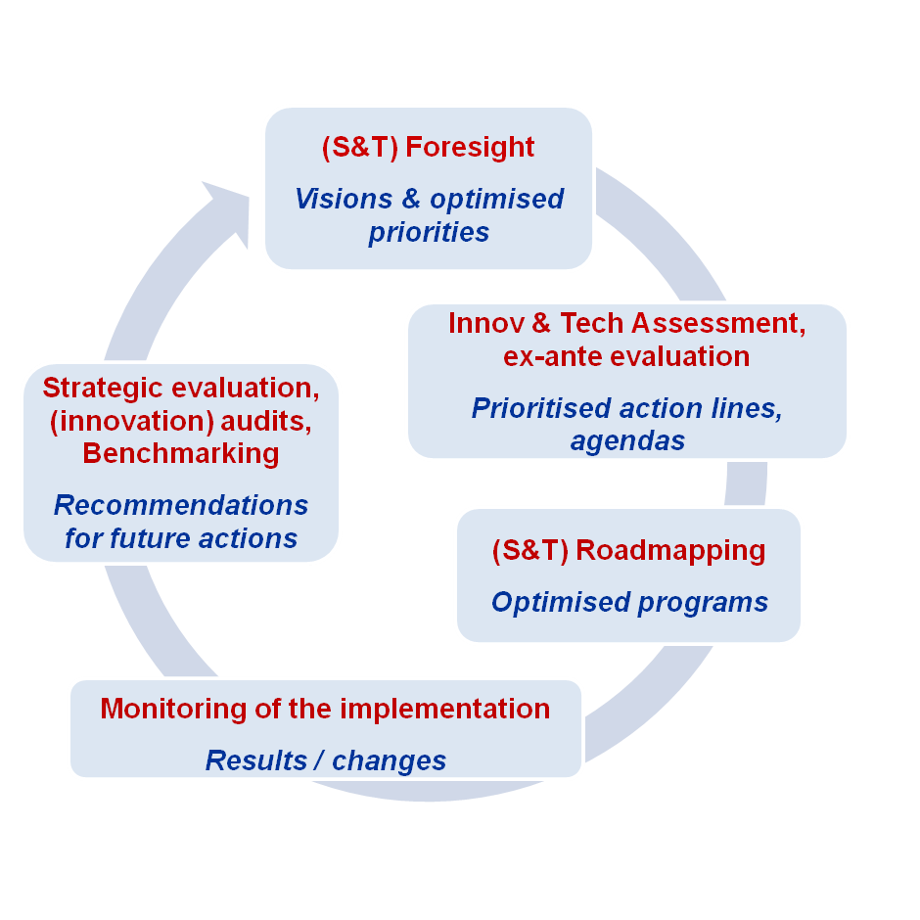
Building on these concepts, the CReATE project (Creating a Joint Research Agenda for Promoting ICT Innovations in CI across Europe) developed a novel approach for enhanced strategic, trans-regional cluster development. Mobilising the commitment of and supporting consensus-building among all relevant stakeholders, project activities included trans-regional vision-building, priority-setting, project development and programme coordination across CI clusters in Baden-Württemberg (DE), Piemonte (IT), Rhône-Alpes (FR) and West-Midlands (UK).

From Music Composition
to Architecture
CReATE was co-funded by the EU “Regions of Knowledge” (RoK) initiative, which aims to strengthen the research potential of European regions by encouraging and supporting the development of regional research-driven clusters.
The seven project partners, including public authorities, cluster managing organisations, technology transfer and research organisations, aim to increase CI competitiveness, market potential and outreach to other industry sectors by making more systematic use of ICT’s innovation potential.
To make the best use of their different RTDI support histories (EU, national, regional), factor and demand conditions, and strengths in the CI field, the partners worked with a common methodology (developed in an earlier RoK project) towards common overall priorities – and, on this base, developed different, regionally optimised applications. SPI tools were applied to identify promising RTDI priorities as a key ingredient of sustainable cluster growth, to foster trans-regional knowledge exchange more effectively and successfully, and to optimise the use of regional, national and EU infrastructures and programmes.
Regional
Priorities
for
Applied
Research
global
trends
Application
Areas
Creative
Industries
ICT Research
Areas
Regional Impact
Opportunities
&
Threats
RTDI
Stakeholders
& Initiatives
Regional
Priorities
for
Applied
Research
Global
Trends
Application
Areas
Creative
Industries
ICT Research
Areas
Regional Impact
Opportunities
&
Threats
RTDI
Stakeholders
& Initiatives
RTDI
Stakeholders
& Initiatives
CReATE supports European co-operation of innovative clusters and focuses on the following six CI segments:
- music composition and production,
- film, television and video,
- animation and computer games (entertainment software),
- writing, publishing and print media,
- advertising, graphic design and marketing,
- architecture, visual arts and design.
Applying Strategic
Policy Intelligence Tools
Based on a methodology developed in the earlier RoK project RegStrat (SPI Tools for Better S&T Investment Strategies in Europe's Regions) and the policy support cycle shown above, several SPI tools were applied: innovation analyses and benchmarking were followed by foresight-type and impact assessment activities and resulted in recommendations for joint projects and for optimising RTDI programmes. The recommendations were adapted to the specific needs and policy objectives of the participating regions. To ensure both regional and trans-regional impact, the overall process was designed in an iterative way, alternating between and mutually enriching the different governance levels.
Stock-taking:
Developing a Regional Knowledge Base
As a sound basis for the analysis of the state of play regarding the regional CI and ICT research potential and the identification of regional ‘fields of aspiration’, a background paper described general future trends and drivers in ICT research relevant for the application in CI. Based on this and the regional analysis template prepared by the strategy consultants of Steinbeis-Europa-Zentrum (SEZ), each region conducted stakeholder interviews and desk research to elaborate a comprehensive set of data and information on CI and ICT innovations. These regional knowledge-generating activities resulted in comprehensive regional reports including cluster maps and detailed SWOT-analyses.
Forward-looking:
Identifying Regional Research Priorities
Prospective activities were undertaken in form of two workshops in each region, designed and supported by foresight consultants to ensure adequate and comparable results.
The first regional stakeholder workshop elaborated a common perception of important trends and drivers of possible future developments in CI. Then, key opportunities and challenges to be faced with regard to the regional strengths and weaknesses from the previous SWOT analysis were identified.
The second workshop developed a shared understanding of the possibilities arising from ICT RTDI for CI and derived a ‘ranking’ of regional research priority areas.
Outward-looking:
Developing a Joint Research Agenda
and Elaborating Joint Project Ideas
Based on the regional results, the identified ICT research capacities, the CI needs and the defined research priorities were related to each other, and joint priorities relevant to all project regions were identified. These were discussed with regional stakeholders and EU representatives during an international IC conference in Turin.
Subsequently, a synthesis report was drafted summarising the results of all regional activities. It also presented the five trans-regional research priorities that would form the basis of the Joint Research Agenda (JRA):
- Visual and Interactive Experience: new visual dimensions and digital interaction between humans and computers (3D internet, virtual worlds, simulations and computer-generated imagery).
- Tools of Productivity and Intelligent Automation: improved productivity and semantic software (rapid prototyping, conversion of 2D visualisations to 3D, more precise combination of web and database content).
- Digital Distribution: new distribution channels on the World Wide Web (collective availability of user-generated content, new markets and revenue streams).
- Mobility and Interoperability: a new level of flexibility in the mobile age (any time, any place access to information, location-related and personalised mobile services).
- User-Producer Interaction in Development: new production methods featuring user-generated content.
The JRA was based on a trans-regional analysis (‘match-making’) and enriched by input and feedback from regional stakeholders. It includes an outline of the current situation as well as future development perspectives, strategic research areas for CI and, more specifically, a comprehensive depiction of the CReATE transregional research priorities. Future lines of action and promising implementation activities for the CReATE and other regions were also outlined.
In line with this, the project partners and relevant stakeholders formulated promising cross-regional, cross-cluster project ideas and concepts. Feasibility and relevant funding opportunities were also scrutinized.
The implementation of these project ideas is not part of the CReATE project. However, as it plays a vital role for the sustainable impact of the whole process, the regional project partners aim to support and encourage regional stakeholders to continue the work in this sense. Also, the strategic CReATE results were designed in a way that they could be utilised in the medium-term for broader and long-term trans-regional cooperation and for the purpose of optimising regional research programmes and policy development more generally.
Increasing Project Impact and Outreach
The European outreach of the project was addressed by transforming the project methodology and good practices from the partner regions into a generally applicable and easy-to-use toolkit for all European actors. Furthermore, the know-how gained during the project served as input to interactive training and capability-building workshops for interested regions. By June 2010, two of these will have been conducted in the greater Dublin region and Pomerania, Poland. Even after the end of the project, such workshops can be set up in other regions interested in strategic cluster development.

Leverage Effects for
other Regions and Sectors
CI play an important role in economic growth, both in terms of the sector’s own contribution to GDP and its role in the innovativeness of other economic sectors. Supporting CI clusters in Europe’s regions can thus considerably contribute, directly and indirectly, to regional, national and European competitiveness. Higher, better coordinated and more focused RTDI investments can be achieved if sector or cluster priorities are set based on a broad forward-looking perspective considering future technological, social and political developments on the local and global level.
Thus, future projects, programmes and policies need to focus on how to achieve the agreed direction or facilitate the desired change of direction. Success means that activities are designed and conducted not only aiming "to do things right” but rather "to do the right things right”.
Therefore, strategic guidance, as developed and implemented in the holistic three-stage SPI-supported CReATE approach, will become increasingly important for the long-term economic success of research-driven clusters.
CReATE’s intertwined bottom-up and top-down approach, enhancing cooperation on various levels and between a variety of actors, can lead to a better adjustment, coordination and optimisation of innovation policies on all governance levels.
This is especially attractive for Europe’s regions because, in times where RTDI budgets are stagnating, pooling funds and know-how in joint trans-regional projects can help to make the most efficient and effective use of regional resources and infrastructures.
The CReATE project showed that, by conducting such forward-looking trans-regional activities, comprehensive knowledge and priority generation and its application are facilitated, trans-regional synergies are tapped, internationalisation of regional actors is enhanced and the basis for more economic success is established.
These more general conclusions are based on the concrete lessons learned during the implementation of CReATE:
- The methodology followed a multi-actor, multi-level and multi-disciplinary approach, fostered trans-regional cooperation and thus promoted synergies between regional, national and European initiatives. Similar to the ‘Strategic Research Agendas’ of the European Technology Platforms, the CReATE JRA can contribute to raising public and private RTDI investments at all governance levels and improve their impact through optimising efforts and resources.
- The dialogue-oriented CReATE methodology involved all relevant regional stakeholders of the ‘triple helix’ (university-industry-government) and thus facilitated consensus-building based on personal relationships and mutual trust. The CReATE activities can serve as a starting point for a comprehensive cluster foresight exercise to define a common vision and strategy for a broader approach to sustainable cluster development in the regions. The experiences of the regional CReATE activities show that participatory interactive approaches are a good way to set the scene for joint actions across different regions, sectors and disciplines.
- On the regional level, the stakeholder workshops have shown some barriers between the different business cultures, languages and mindsets between ICT and CI representatives. The challenge for innovation policies, for instance concerning cluster development, is to bridge the gap between these different mindsets and to leverage cross-disciplinary potential to boost innovation and competitiveness in new markets. The CReATE project’s regional stakeholder workshops clearly pointed out the need for specific support actions to optimally utilise the synergies between ICT and CI.
- The trans-regional JRA tapped trans-regional synergies by identifying specific regional needs and capabilities as well as the most promising international technology and market development perspectives. It provided the base for optimised concrete actions, both regionally and trans-regionally, generating a clear added value for the regions. The JRA enables all regional actors (from public to private sphere) to rethink and eventually to adjust the focus, effectiveness and efficiency of their policies and (business) strategies. A number of project ideas have already been developed among the project partners and will ensure a sustainable impact of the project after its finalisation.
- The CReATE methodology facilitated trans-regional and cross-cluster knowledge flows and learning processes across and beyond the CReATE regions and fostered the integration of the CReATE regions into international innovation networks. In this context, broadening and deepening the cross-regional activities beyond the project time frame is valuable to fully capitalise on the added value provided by this methodological approach.

Sources and References
- Project websites: www.steinbeis-europa.de/index.php5?file=484; www.lets-create.eu; www.regstrat.net
- Contact persons as mentioned above
- See, e.g., http://www.europe-innova.eu/web/guest/home/-/journal_content/56/10136/178407

About the EFP: Policy professionals dealing with RTD, innovation and economic development increasingly recognize a need to base decisions on broadly based participative processes of deliberation and consultation with stakeholders. Among the most important tools they apply are foresight and forward looking studies. The EFP supports policy professionals by monitoring and analyzing foresight activities and forward looking studies in the European Union, its neighbours and the world. The EFP helps those involved in policy development to stay up to date on current practice in foresight and forward looking studies. It helps them to tap into a network of know-how and experience on issues related to the day-to-day design, management and execution of foresight and foresight related processes.

